Enable I2C before install Palette

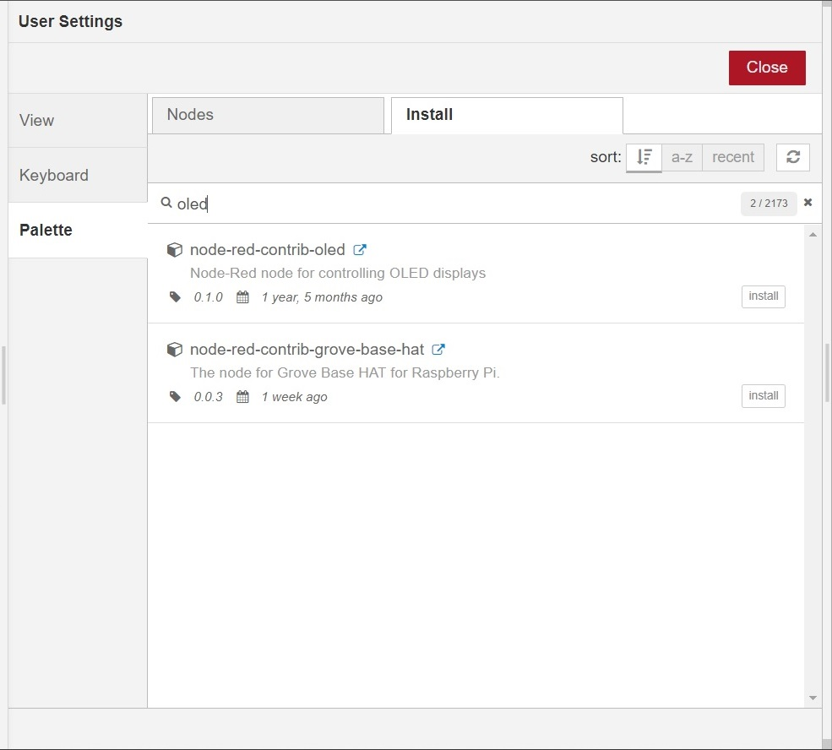

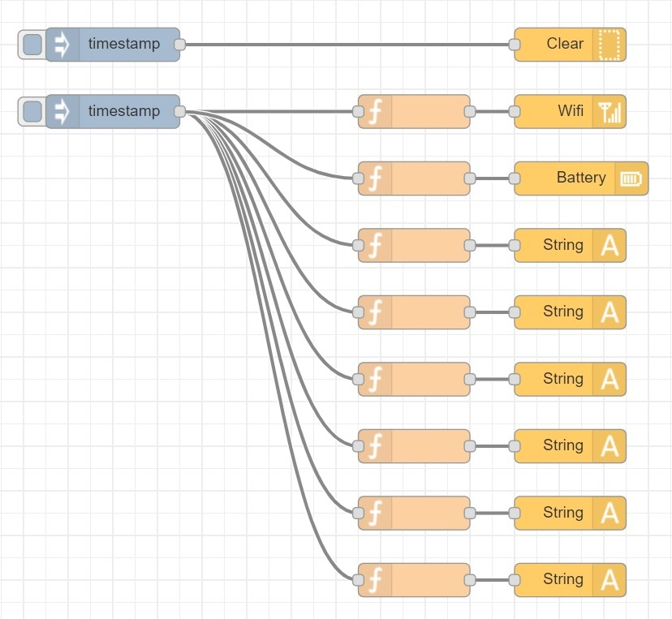

|  |
| --- |
| [{"id":"a019d070.d6562","type":"tab","label":"Flow 1","disabled":false,"info":""},{"id":"5e1f078b.af0478","type":"inject","z":"a019d070.d6562","name":"","topic":"","payload":"","payloadType":"date","repeat":"","crontab":"","once":false,"onceDelay":0.1,"x":200,"y":220,"wires":[["2b55fb58.7dde04","77142c71.daea84","c338947d.7ba648","f3e6ba9e.3eda58","5086ff01.385a5","10b74234.347d0e","e7beeeef.2df8","b94b5812.f46af8"]]},{"id":"7404d28e.e5be3c","type":"String","z":"a019d070.d6562","name":"","display":"3129882c.288d78","x":610,"y":340,"wires":[]},{"id":"2b55fb58.7dde04","type":"function","z":"a019d070.d6562","name":"","func":"msg.payload={size:1,x:1,y:1,text:\"ABCDEFGHIJKLM\"}\nreturn msg;","outputs":1,"noerr":0,"x":470,"y":340,"wires":[["7404d28e.e5be3c"]]},{"id":"401db5ec.d5bc8c","type":"String","z":"a019d070.d6562","name":"","display":"3129882c.288d78","x":610,"y":400,"wires":[]},{"id":"77142c71.daea84","type":"function","z":"a019d070.d6562","name":"","func":"msg.payload={size:1,x:1,y:11,text:\"NOPQRSTUVWXYZ\"}\nreturn msg;","outputs":1,"noerr":0,"x":470,"y":400,"wires":[["401db5ec.d5bc8c"]]},{"id":"b8a65115.aebae","type":"String","z":"a019d070.d6562","name":"","display":"3129882c.288d78","x":610,"y":460,"wires":[]},{"id":"c338947d.7ba648","type":"function","z":"a019d070.d6562","name":"","func":"msg.payload={size:1,x:1,y:21,text:\"abcdefghijklm\"}\nreturn msg;","outputs":1,"noerr":0,"x":470,"y":460,"wires":[["b8a65115.aebae"]]},{"id":"7fc71009.340a2","type":"String","z":"a019d070.d6562","name":"","display":"3129882c.288d78","x":610,"y":520,"wires":[]},{"id":"f3e6ba9e.3eda58","type":"function","z":"a019d070.d6562","name":"","func":"msg.payload={size:1,x:1,y:31,text:\"nopqsrtuvwxyz\"}\nreturn msg;","outputs":1,"noerr":0,"x":470,"y":520,"wires":[["7fc71009.340a2"]]},{"id":"23245d5e.e83f62","type":"String","z":"a019d070.d6562","name":"","display":"3129882c.288d78","x":610,"y":580,"wires":[]},{"id":"5086ff01.385a5","type":"function","z":"a019d070.d6562","name":"","func":"msg.payload={size:1,x:1,y:41,text:\"0123456789\"}\nreturn msg;","outputs":1,"noerr":0,"x":470,"y":580,"wires":[["23245d5e.e83f62"]]},{"id":"29397347.9b4bec","type":"String","z":"a019d070.d6562","name":"","display":"3129882c.288d78","x":610,"y":640,"wires":[]},{"id":"10b74234.347d0e","type":"function","z":"a019d070.d6562","name":"","func":"msg.payload={size:1,x:1,y:51,text:\"shahrulnizam.com\"}\nreturn msg;","outputs":1,"noerr":0,"x":470,"y":640,"wires":[["29397347.9b4bec"]]},{"id":"2dcf18e6.5d7418","type":"Battery","z":"a019d070.d6562","name":"","display":"3129882c.288d78","x":620,"y":280,"wires":[]},{"id":"88283b6f.e54558","type":"Wifi","z":"a019d070.d6562","name":"","display":"3129882c.288d78","x":610,"y":220,"wires":[]},{"id":"b94b5812.f46af8","type":"function","z":"a019d070.d6562","name":"","func":"msg.payload={x:100,y:21,p:100}\nreturn msg;","outputs":1,"noerr":0,"x":470,"y":280,"wires":[["2dcf18e6.5d7418"]]},{"id":"e7beeeef.2df8","type":"function","z":"a019d070.d6562","name":"","func":"msg.payload={x:100,y:1,p:100}\nreturn msg;","outputs":1,"noerr":0,"x":470,"y":220,"wires":[["88283b6f.e54558"]]},{"id":"b6d9e9d5.400ab8","type":"inject","z":"a019d070.d6562","name":"","topic":"","payload":"","payloadType":"date","repeat":"","crontab":"","once":false,"onceDelay":0.1,"x":200,"y":160,"wires":[["3a4cd2e2.8e7e0e"]]},{"id":"3a4cd2e2.8e7e0e","type":"Clear","z":"a019d070.d6562","name":"","display":"3129882c.288d78","x":610,"y":160,"wires":[]},{"id":"3129882c.288d78","type":"oled-config","z":"","name":"OLED","width":"128","height":"64","address":"3c"}] |